**Waste Table 3–Designing our product packaging for circularity**

In FY23, we achieved a rate of 93.9% recyclability across all Microsoft product packaging.

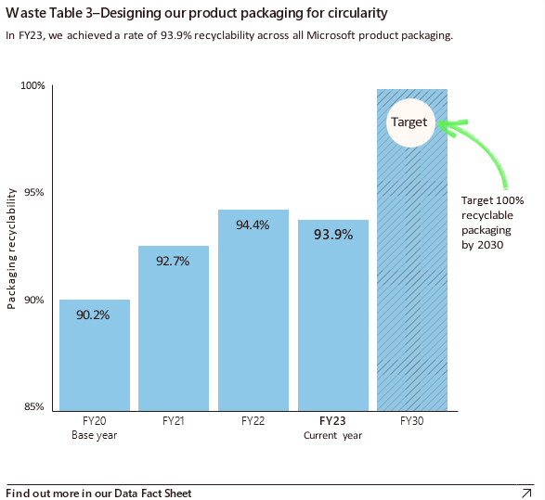

Bar graph showing the achieved rate of recyclability across all Microsoft product packaging from fiscal years FY20 to FY30. The X-axis displays the fiscal years, while the Y-axis represents the packaging recyclability percentage. The data reveals a gradual increase in packaging recyclability, starting at 90.2% in FY20, rising to 92.7% in FY21, further increasing to 94.4% in FY22, slightly decreasing to 93.9% in FY23, with a target of achieving 100% recyclable packaging by FY30.